Edit the **css/style2.css** file to change the style of your website

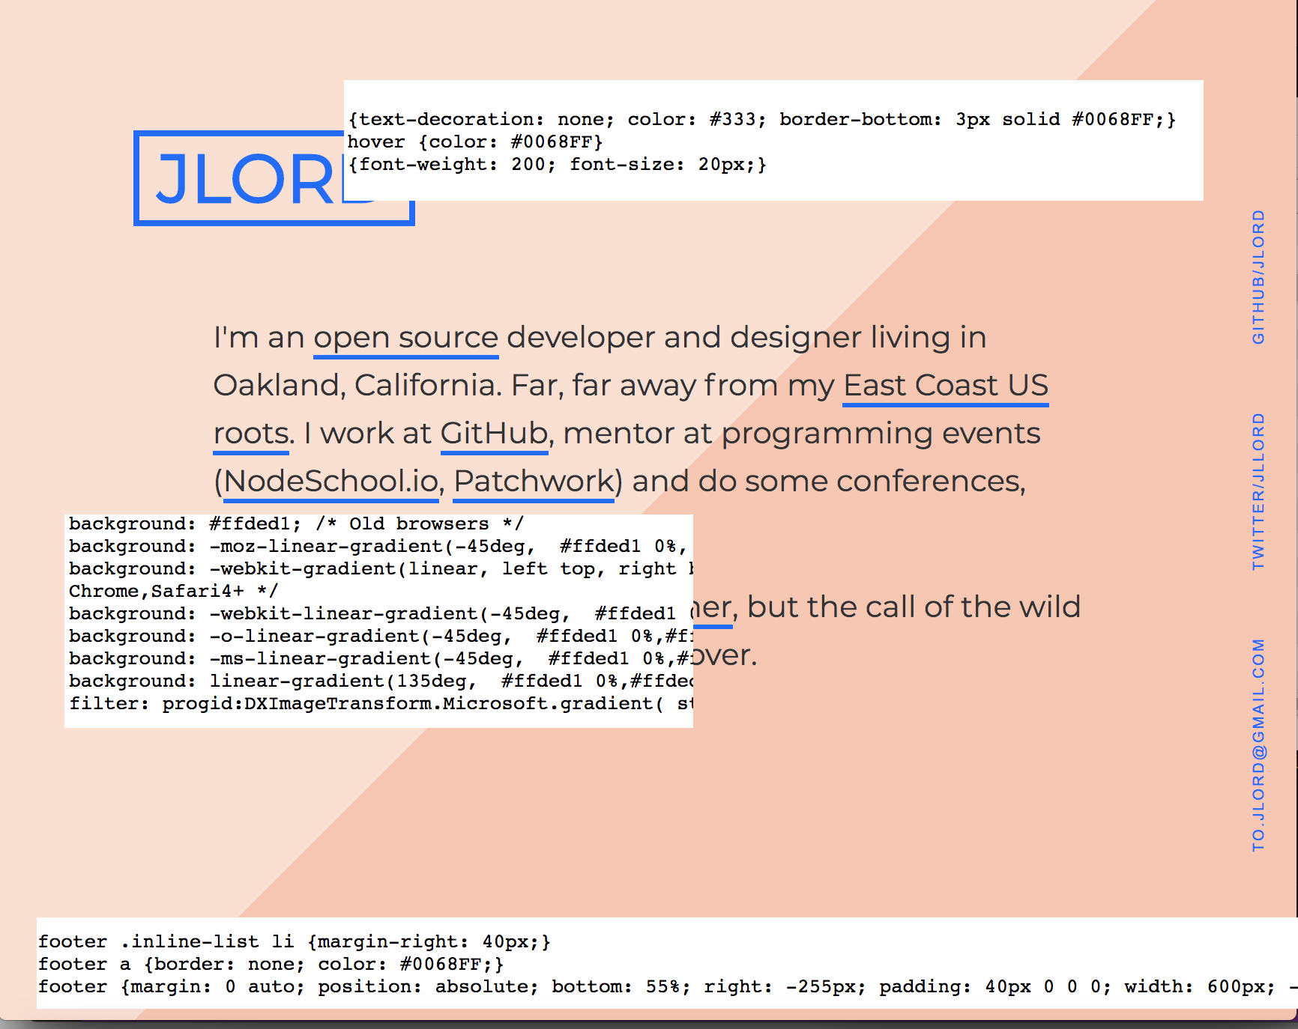



To change the background color, get rid of the gradient (this give the page the split, 2-tone effect).

Then, add a new color to background.

If you want to play with the gradient, try a background generator:

www.colorzilla.com/gradient-editor

Find and replace #0068FF to change the colors of the links, heading and heading border.

To find more colors, try www.color-hex.com



To change the footer from vertical to horizontal, delete the last line for the footer